JsonWebToken

Without Token.
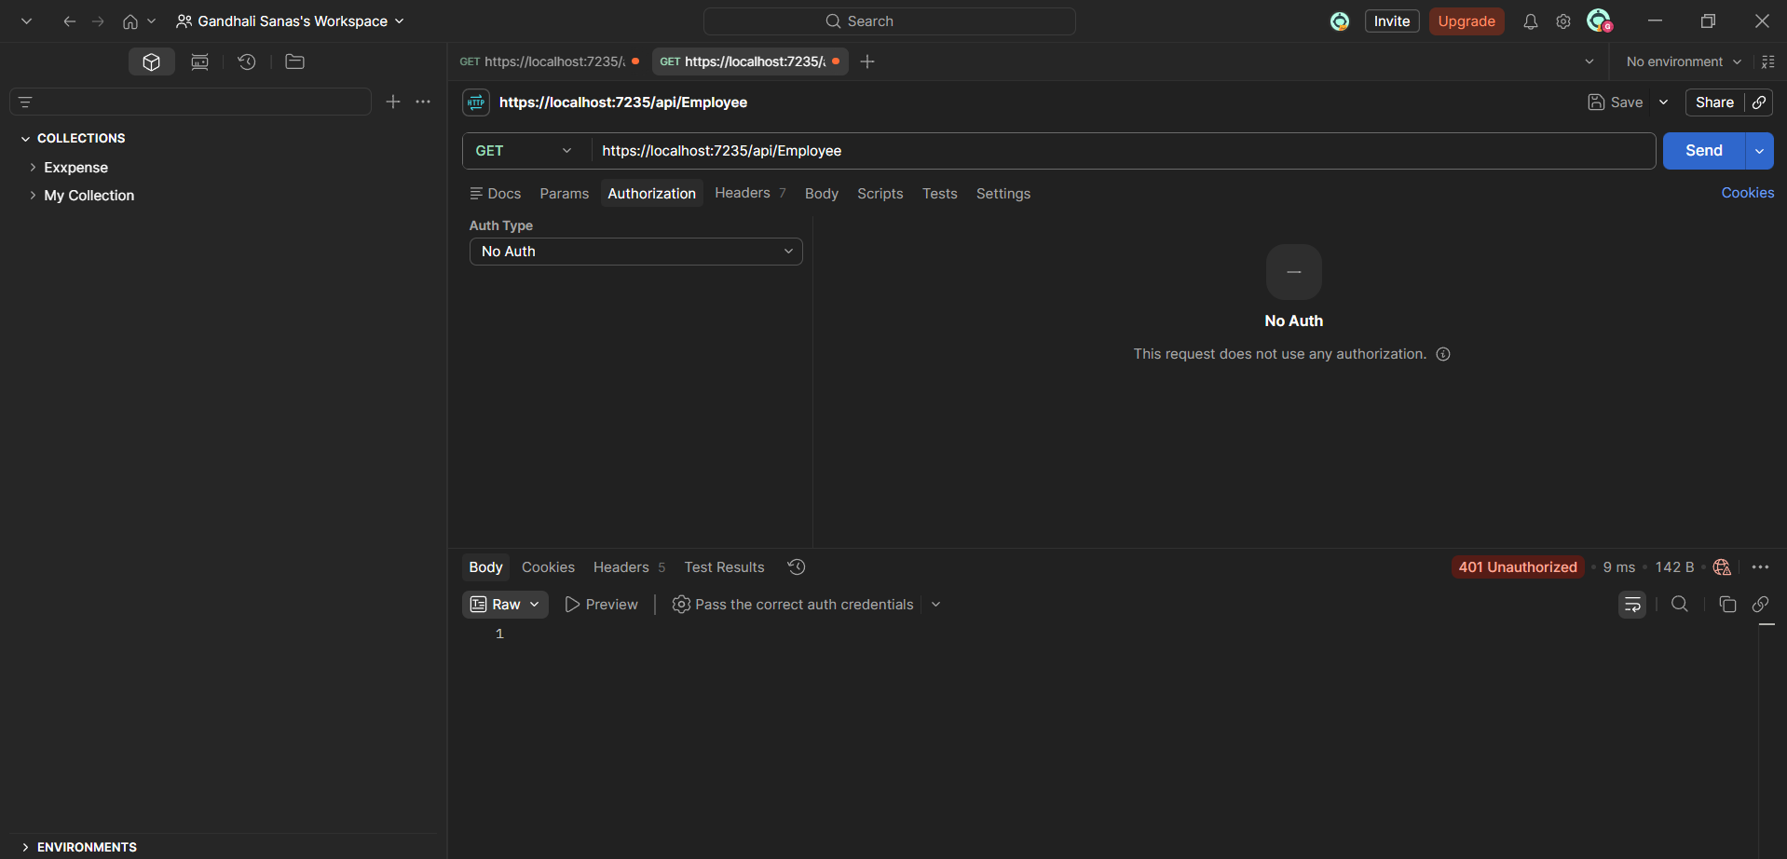

With Valid JWT Token
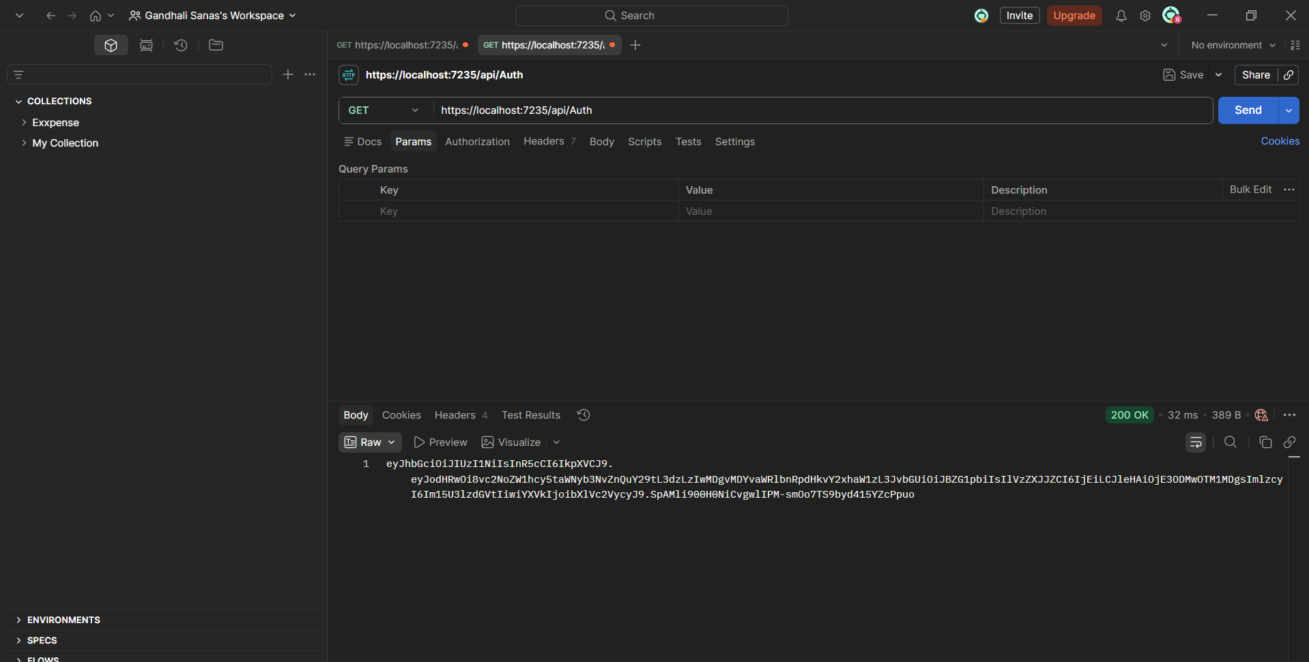

Using valid token and passing to authorization tab
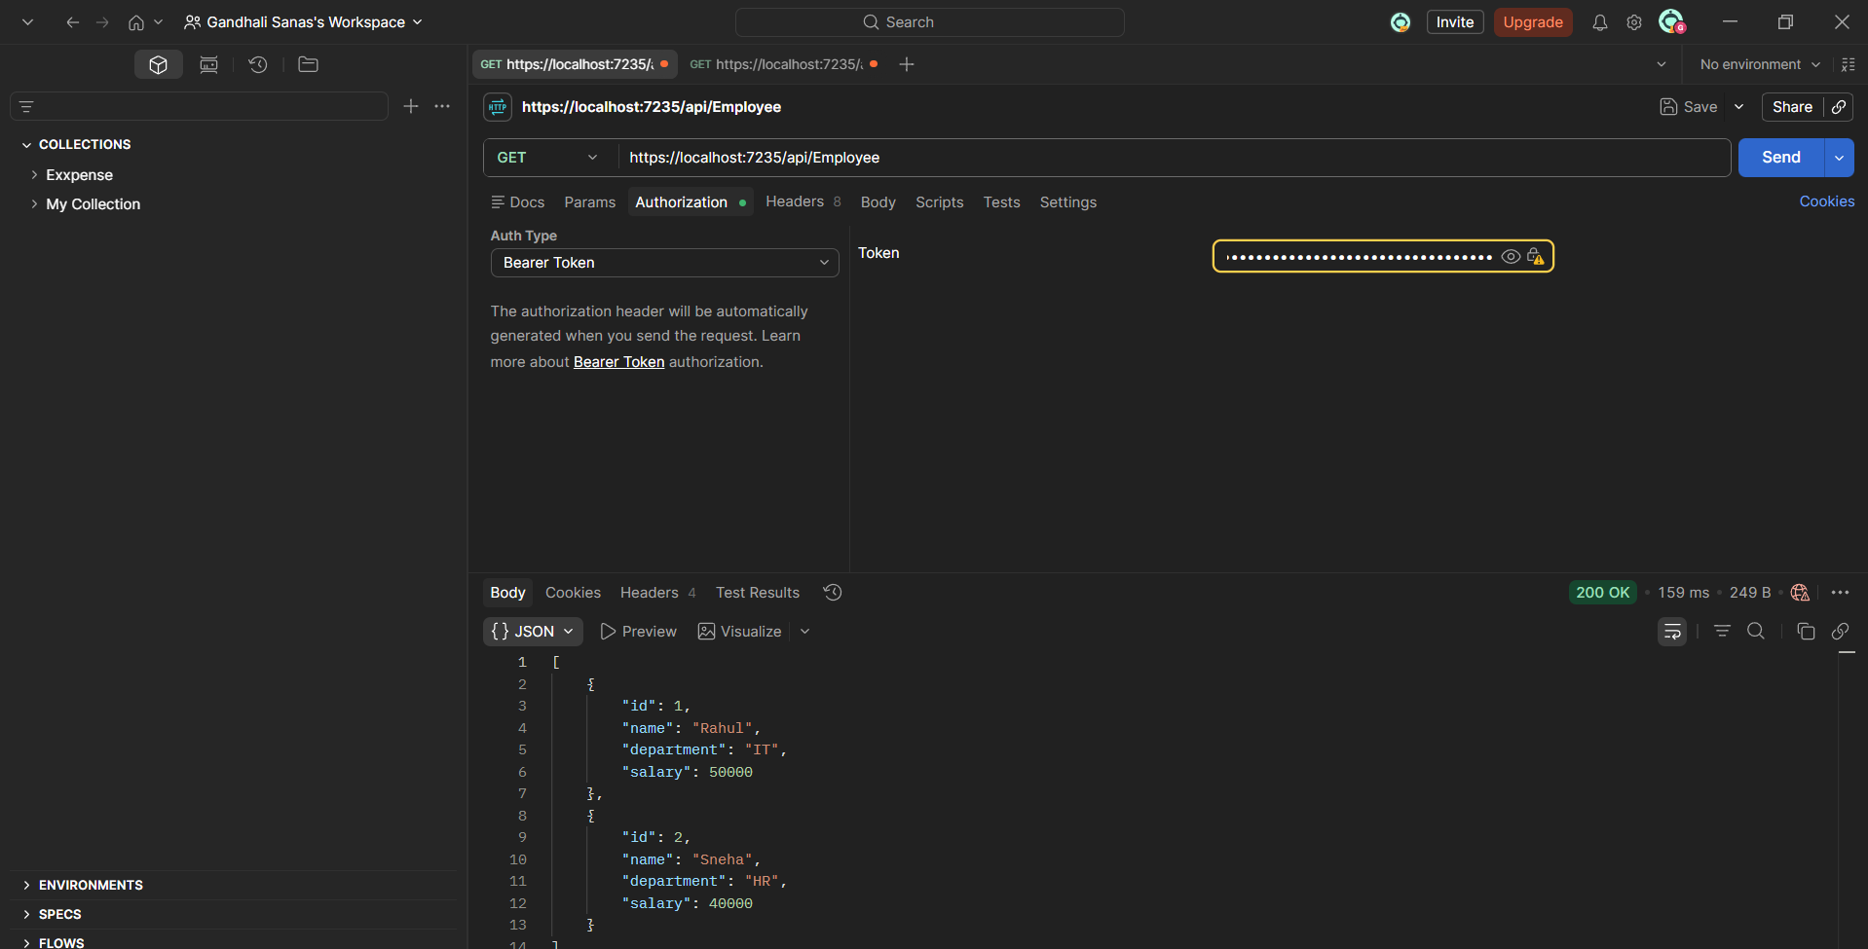

Invalid token
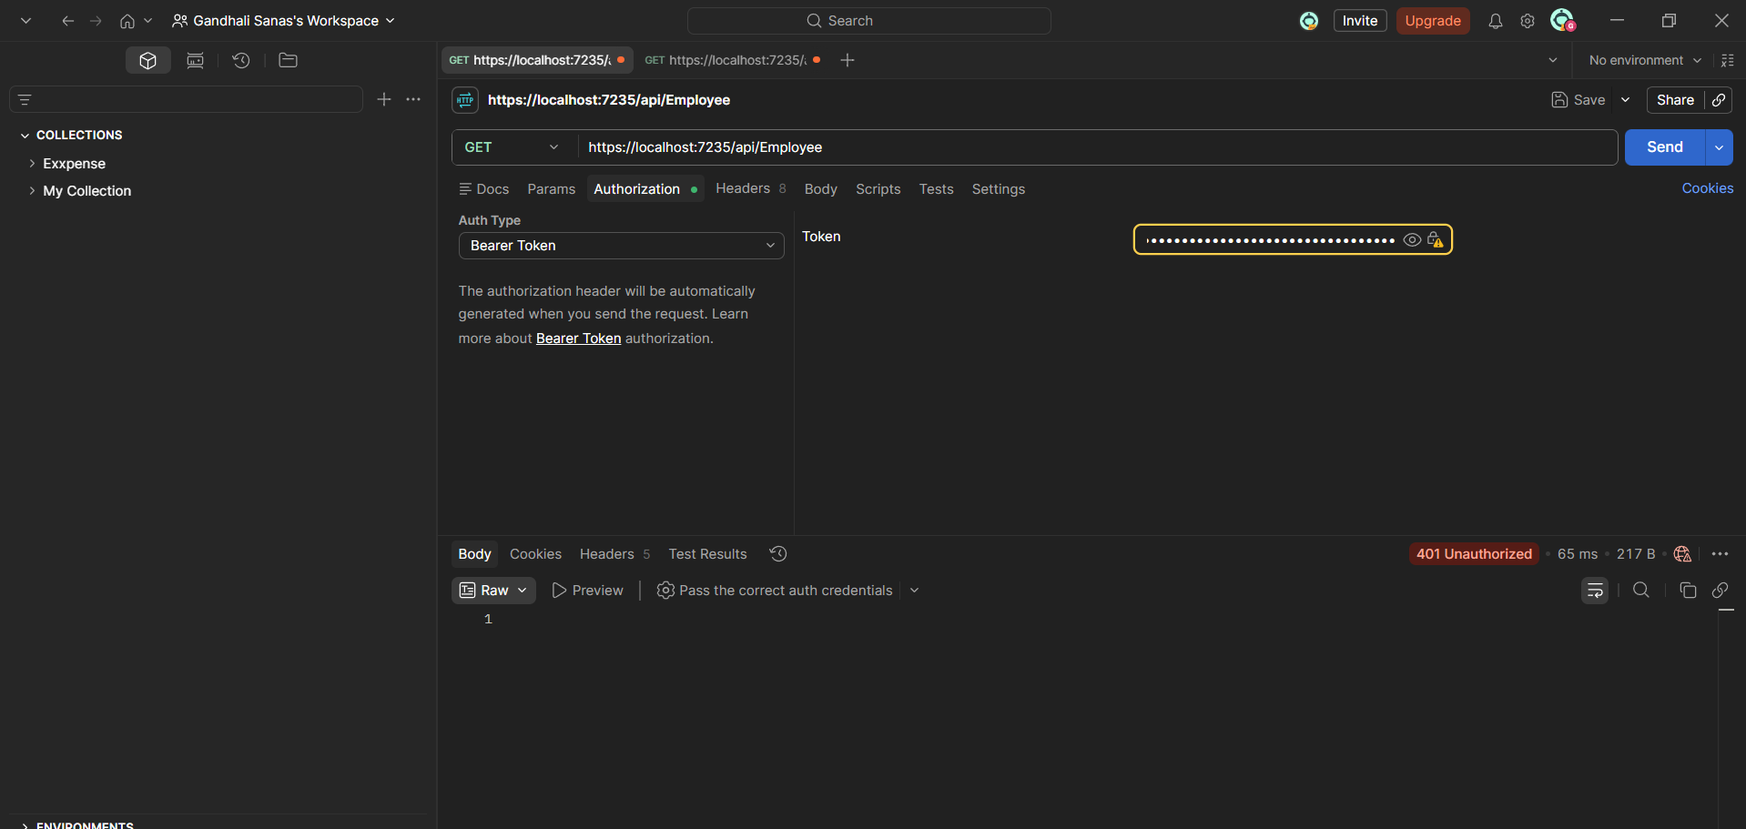

Check for JWT expiration.
Modifying the duration to 2 minutes.
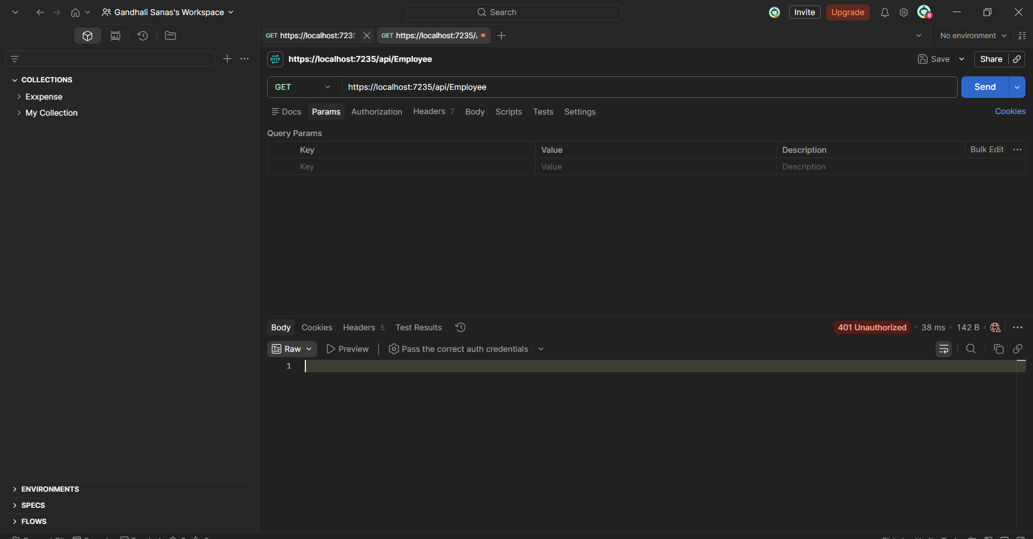

Including the role ‘POC’ in the Authorize attribute in the Employee controller.
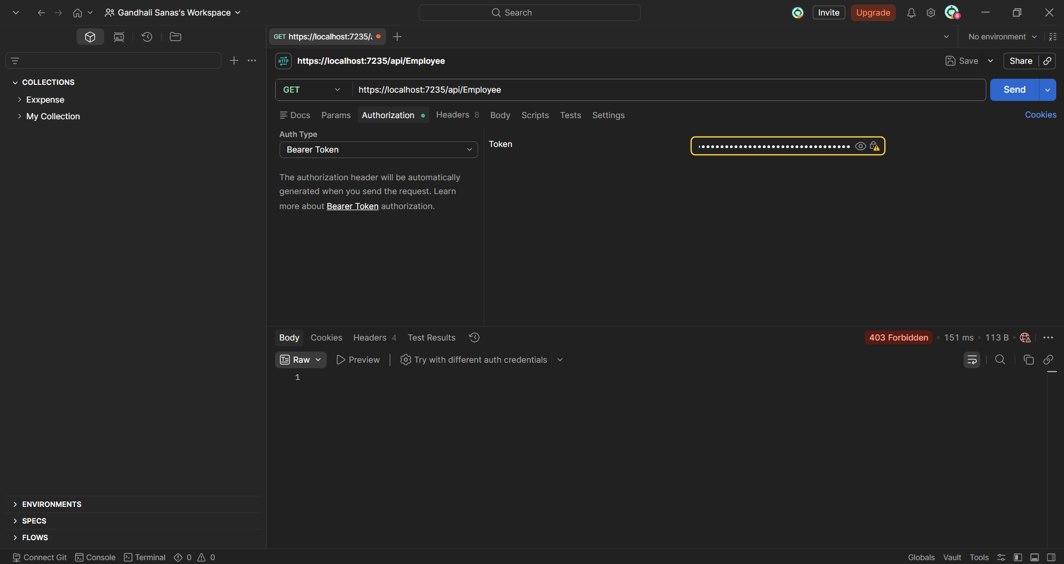

Include the role ‘Admin’ along with ‘POC’ in the Authorize attribute in the Employee controller.
